Android PHone Remote Pointing Device

Supervisor: Dr Paul Scott 2nd Assessor: Dr Sam Steel

Author: Jenothan Premarajah

Initial Report

Content

1. Introduction 2
2. Goals 2
   1. Project Goal 2
   2. System Goal 2
   3. Methodology 3
3. Background Reading 4

3.1 Android 4

1. Technology 4

4.1 Android Phone 4

4.2 Computer 4

4.3 Eclipse 5

4.4 Version Control 5

1. Planning 5

5.1 Initial Report 6

5.2 Interim Report 7

5.3 Implementing & Test 8

5.4 Poster Design 9

5.5 Final Report 10

1. References 11
2. Introduction

­In this report I will write about the stages I have planned out for my final year project which is based on building a remote pointing device android application. I will call my mobile app, Air Mouse. The app will allow users to control the cursor on a computer through an android smartphone by using the touchscreen to control the cursor. Users will also be able to make mouse clicks on the app and have the option to use the keyboard to type remotely.

The project had to be slightly changed due to the fact that I could not get hold of a smartphone that included an accelerometer. Therefore, the tilting of the phone feature to control the mouse cursor could not be added to my project.

1. Goals

2.1 Project Goal

The main goal of this final year project is to create a mobile application for the android platform that will allow users to control a computer mouse cursor using an android phone. The phone will act as a remote mouse and has the option to act as a remote keyboard.

2.2 System Goal

In this section I will list some of the system goals as for this project in this initial stage:

* The android device and the computer will communicate by means of a client-server mode.
* The server software for Air Mouse will be developed for the computer to enable it to communicate with the phone.
* The Java programming language will be used to develop the android mobile app and the server software, using Eclipse IDE.
* The android phone and the computer will need to be connected to the same network in order for communication between the client and server to take place.

I have thought about making the application cross-platform so I could reach a wider audience by allowing the app to be used by a variety of platforms rather than just an Android.

After doing some research I concluded that I would keep it simple and just stick with coding for the android platform, as this will give allow me to focus deeply on the android API rather than focusing on multiple platforms.

However, making the mobile application multi-platform could be a future improvement.

2.3 Methodology

I will take the agile software development method path to develop my app.

[1] The agile method develops software incrementally by having regular sprints, which is when a group of people related to the project get together and focus on the progress and development of the project. Sprints can last usually about a month or less.

Each sprint ends with the release of a component of the software, for example a feature of the end product or a function inside the software.

Figure 1 shows the basic cycle of the agile process, started at the Production stage and finished in the Test stage if there are no bugs found.

I will not be having regular get-togethers as I am a one-man team for my project, but I will be having sprints where I focus on a part of the system for a few days and end it with a deliverable and then test that feature/function before moving on. The project will therefore be incrementally built.

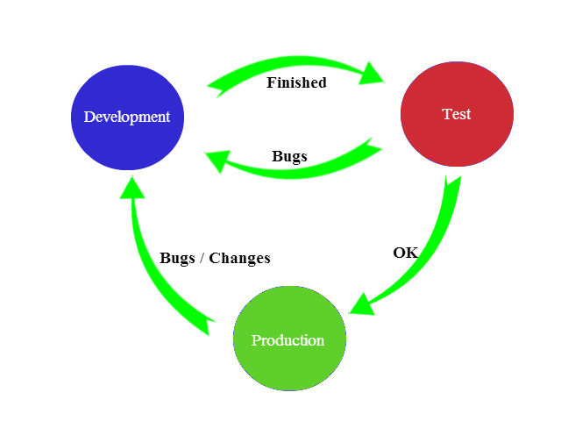

Figure 1: Agile Development Process

1. Background Reading

My background knowledge on android application development was little. I had taken my time to research on the development of mobile application by creating a simple app for my android phone to ensure I know the basics of mobile application development before I start my project.

I also did some market research by looking on the Google Play Store online to find apps that are similar to what I was going to build.

I found an app called Remote Mouse which allows a device to connect to a computer and control its cursor by using the touchpad on the device. The app required that the Remote Mouse Server was installed on the computer that was going to be controlled and it was required that both the computer and the android device were connected to the same network.

I figured that the application was based on a client-server model, which is the approach I will be taking for my mobile app. I had also figured that the server software for Remote Mouse was written in a different language other than Java, as it was an executable file. I went onto to find other mobile apps that were similar to my project such as AndroMouse, RemoteDroid and many more.

3.1 Android

[2]”Android is a mobile operating system running on the Linux kernel. It was initially developed by Android Inc., a firm later purchased by Google, and lately by the OPA (Open Handset Alliance)”. Android is an open platform, meaning it is free and open source. This allows outside developers to improve and fix code.

[2]”OPA are a consortium of 47 hardware, software and telecom companies devoted to advancing open standards for mobile devices, which allows developers to write standardised code in the Java language and controlling the device via Google-developed Java libraries”.

1. Technology

In this section I will talk about the technologies involved throughout my project.

4.1 Android Phone

I will be using my own Android phone throughout the project for testing purposes. The model of the phone is Samsung i5500 and the main hardware support that we will be requiring for this project is the touchscreen and Wi-Fi that the phone provides. The phone consists of a 600 MHz CPU. The Air Mouse app will be installed on this phone to be tested on.

4.2 Computer

The mobile application and the server software will be developed on a Windows 7 operating system using the Eclipse IDE (Integrated Development Environment). The server will be installed on the computer to allow communication with the Android phone through a client-server type model. This communication will consist of data such as the movement of the finger on the touchscreen of the Android phone being transferred.

4.3 Eclipse

The mobile application will be developed in Eclipse using the Android API package. The emulator in Eclipse will be used to test new features and functions before being directly tested on a real Android phone. An emulator is a virtual mobile device that runs on the computer and typically used to test out written code for the target device.

4. 4 Version Control

**Why use version control?**

[3] Version control enables a group of people to work on a single project and each person has their copy of the project. However, they can also choose to share the changes that they have made with the rest of the group.

[3] Version control is also useful when one person is working on a project because the project can be brought up onto multiple computers.

[3] Version control also allows you to retrieve older versions of the project that you have been working on. So when things go wrong, you can also go back to the previous version of your project.

I will be using version control because it allows me to work on my project from my laptop as well as the computers at university. Another reason I will be using version control is because it allows me to keep track of my versions of the project.

The version control software I will be using is GitHub.

1. Planning

I created Gantt charts using Microsoft project to plan my project out.

I have set milestones and stages in the Gantt chart. The Gantt chart has been broken into the separate stages for ease of readability.

The project plan I took was influenced a lot by the deadlines for the reports and poster presentation. I ensured the timeslots were big enough to finish each report, poster, and end-product needed for this project. The tasks in the Implementing and Testing stage have equal start and finish dates, which is from 2nd December 2013 to 14th February 2014. This is because I was taking the agile development approach and did not want a set finish date for each task so that it will be more flexible for change during development.

5.1 Initial

Report

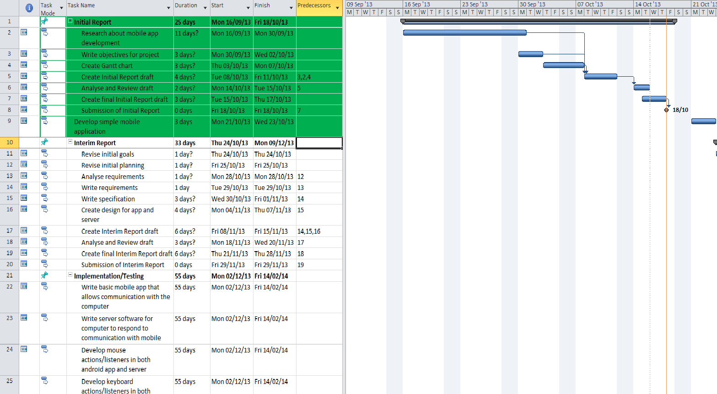

5.2 Interim

Report

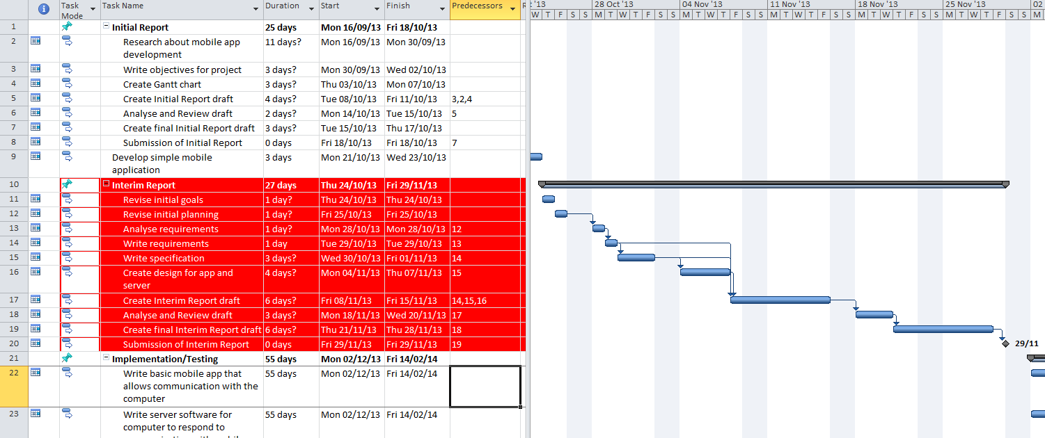

5.3 Implementation

& Testing

The start dates for all the tasks inside this summary are from 02/12/13 to 14/02/14 this is because I am using the iterative agile method.

Hence why I decided to give this stage in the project a bigger timeslot overall, where the product will be planned, implemented and tested incrementally.

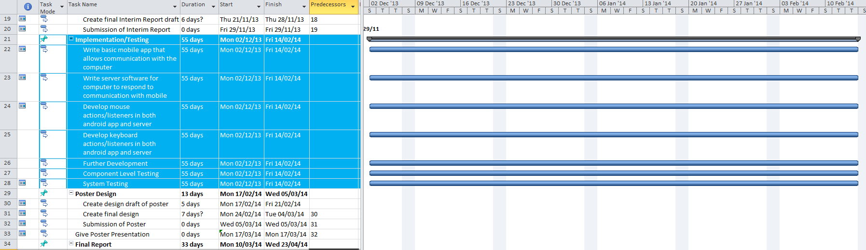

5.4 Poster

Design

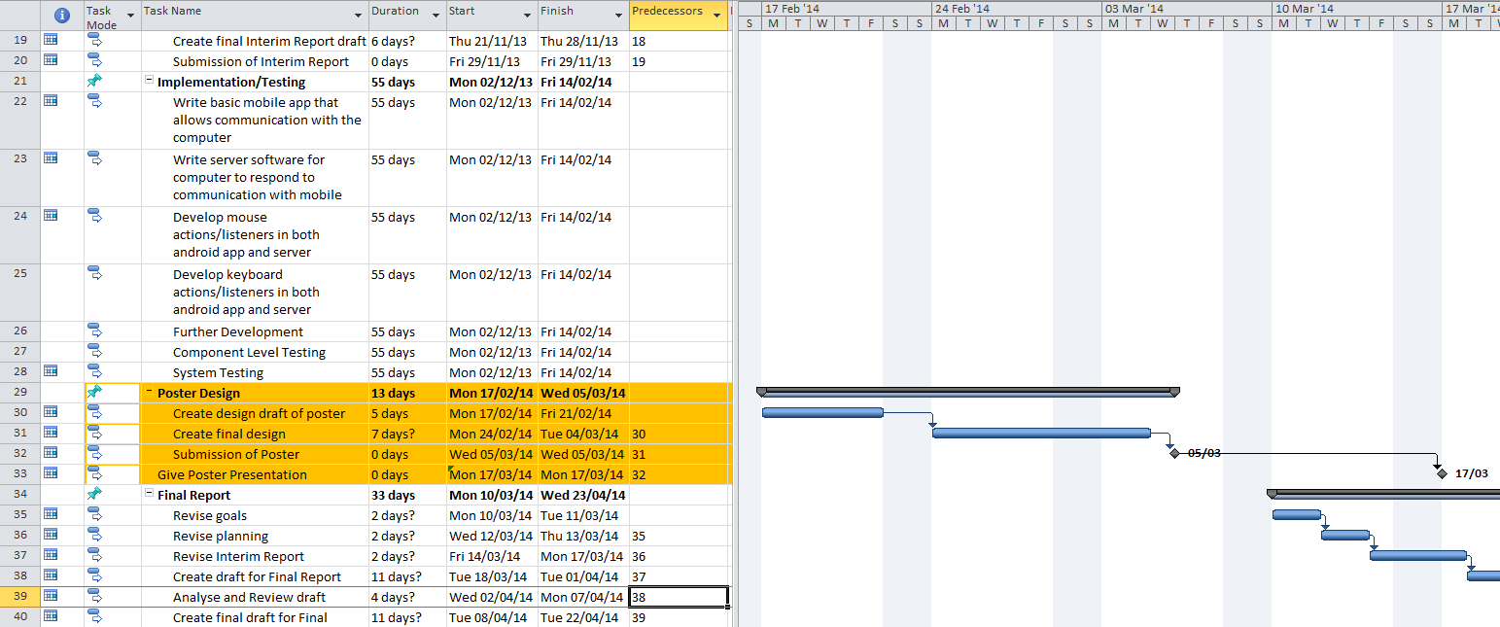

5.5 Final Report

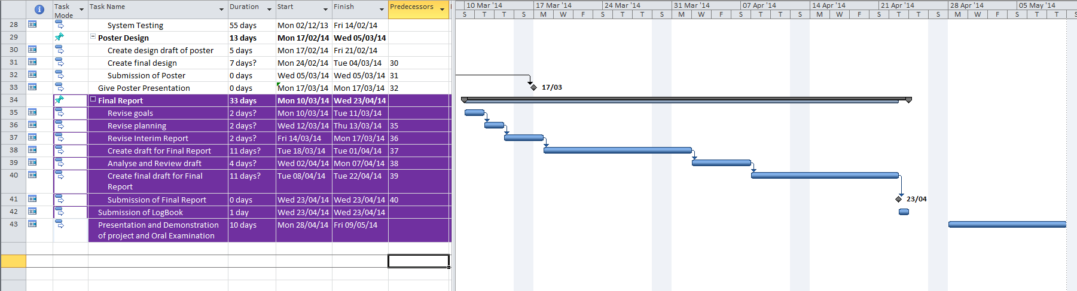

6. References

[1] L. Williams, “A Survey of Agile Development Methodologies,” 2007.[Online]. Available: <http://agile.csc.ncsu.edu/SEMaterials/AgileMethods.pdf>

[2] J. M. Wei Duan, “The research of Android System Architecture and application programming,” 24December 2011. [Online] .Available: <http://0-ieeexplore.ieee.org.serlib0.essex.ac.uk/stamp/stamp.jsp?tp=&arnumber=6182081>.

[3] M. Ernst, "Version control concepts and best practices," 19 April 2013. [Online]. Available: <http://homes.cs.washington.edu/~mernst/advice/version-control.html>.

[4] Lecturer, “Tutorial on Client-Server Communications,” , Autumn 2013. [Online]. Available: <http://www.stanford.edu/class/ee368/Android/Tutorial-3-Server-Client-Communication-for-Android.pdf>

[5] Image URL: <http://www.lotaris.com/sites/default/files/blog-images/android_vector.jpg>